4. Fit Line
In our experiments we have some different values often does not match each other. However, we have to find an equation of the correlation between two factors. Thus, we draw a line called fit line to represent average trend between two values. In this experiment we should represent the correlation between acceleration and kinetic friction coefficient values.

I use numpy and matplotlib modules in Python to draw a graph and find the equation of fit line fit line of acceleration and kinetic friction coefficient values. First I place the values on the graph and visualize them.

#define max force and max velocity * max velocity data
force = np.array([1.245, 1.262, 1.251, 1.239, 1.215, 1.245, 2.248, 2.468, 2.462, 2.951, 2.969, 3])
velocitySquaredMax = np.array([1.298, 1.143, 1.316, 1.274, 1.304, 1.286, 2.557, 2.533, 2.527, 3.112, 3.076, 3.153])

#add points to plot
plt.scatter(force, velocitySquaredMax, color='steelblue')

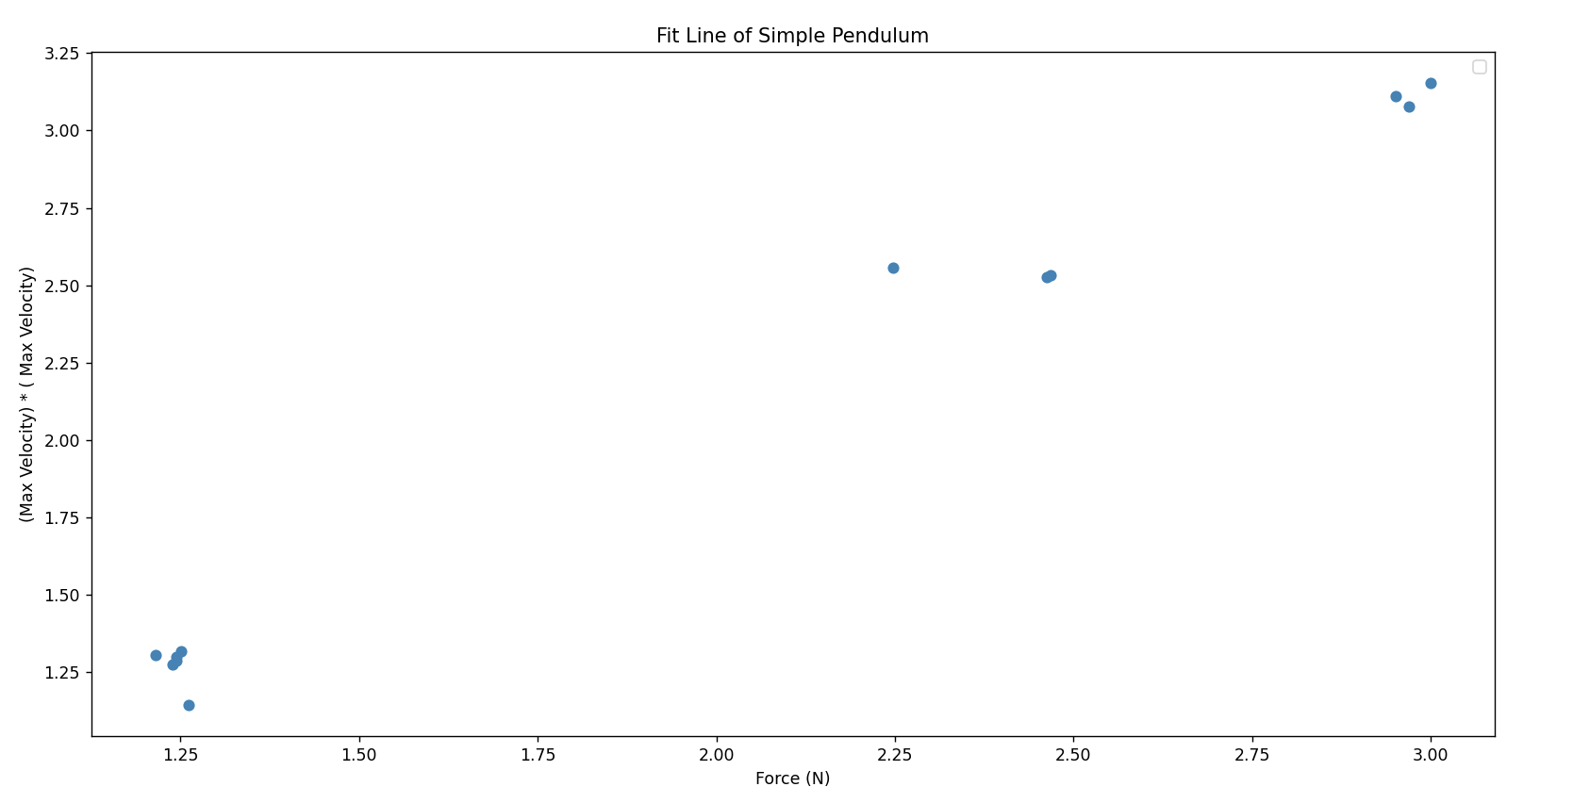
- Figure 1: Values of (Velocity_{max})² and Force Values

Second, I find the fit line equation “f(x) = mx + n” using polyfit() function of numpy module then, I plot the fit line using plot() function of matplotlib module.

#find fit line
m, n = np.polyfit(force, velocitySquaredMax, 1)

#add fit line to plot
plt.plot(force, m*force+n, color='red', linewidth=2, label= 'Fit line: ' + 'f(x) = ' + '{:.3f}'.format(m) + 'x' + ' + {:.3f}'.format(n))

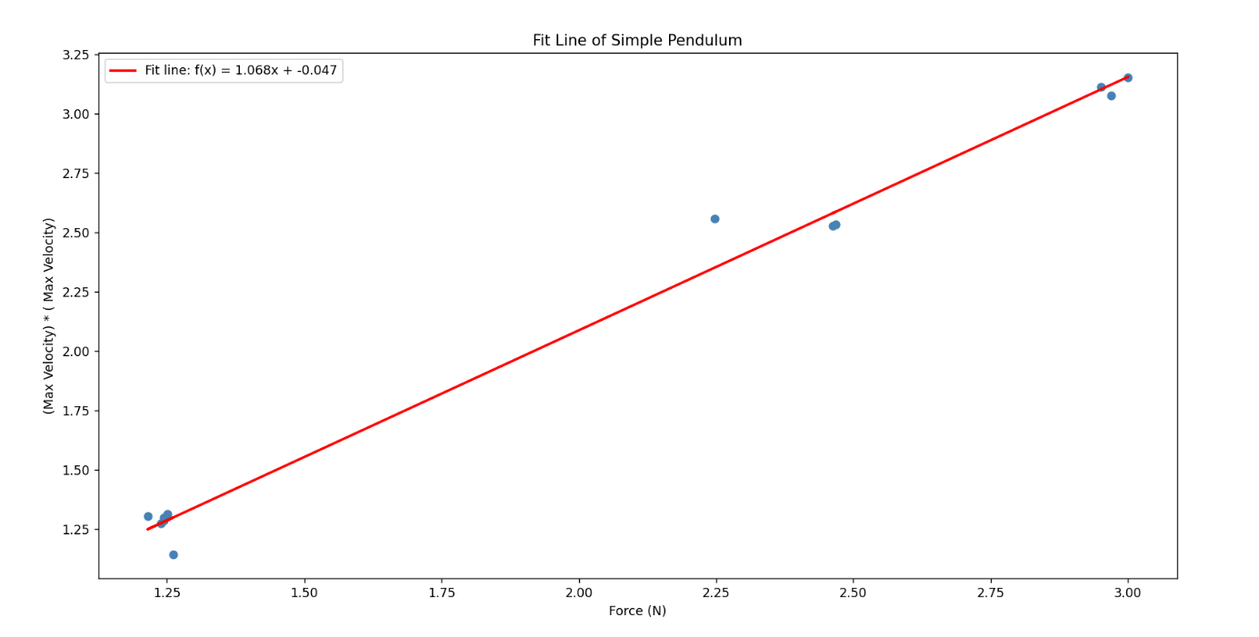
2. Figure 2: Fit Line of Acceleration and Kinetic Friction Coefficient Values

Source Code:
import numpy as np
import matplotlib.pyplot as plt

#define accelerations and kinetic friction coefficients data
force = np.array([1.245, 1.262, 1.251, 1.239, 1.215, 1.245, 2.248, 2.468, 2.462, 2.951, 2.969, 3])
velocitySquaredMax = np.array([1.298, 1.143, 1.316, 1.274, 1.304, 1.286, 2.557, 2.533, 2.527, 3.112, 3.076, 3.153])

#find fit line
m, n = np.polyfit(force, velocitySquaredMax, 1)

#add points to plot
plt.scatter(force, velocitySquaredMax, color='steelblue')

#add fit line to plot
plt.plot(force, m*force+n, color='red', linewidth=2, label= 'Fit line: ' + 'f(x) = ' + '{:.3f}'.format(m) + 'x' + ' + {:.3f}'.format(n))

plt.xlabel('Force (N)')
plt.ylabel('(Max Velocity) * ( Max Velocity)')
plt.title('Fit Line of Simple Pendulum')

plt.legend()
plt.show()

